|  |  |
| --- | --- |
| Personal development plan  Jesse van den Broek | PI&V |

Contents

Introduction 2

Professional identity 2

Past experience 2

What drives me 2

Personal quality’s 2

Personal pitfalls 3

Vision 4

Goals 5

# Introduction

Who am I, and who do I want to be as a designer? How do I see the future, and what influence do I want to have? It is important to have an answer to these questions. It enables one to be able to set clear goals for themselves, but also it gives them a larger understanding about themselves, what drives them, what they want to add to the world.

This document reports my search and development of my own professional identity and vision by setting goals and reflecting on past activities.

# Professional identity

## Past experience

I’ve always enjoyed combining technology together with creativity, as well as applying technology to make stuff. As child I already enjoyed making simple robots with a simple all in one kit and instructions. Around 1 to 2 years ago I discovered the Arduino, and started programming and building little games and projects. Different small projects like an attempt to build a simple game using Unity or experimenting with building a website always gave me much joy, even though they were often not really in depth.

My goal as designer is to combine these interests together with my will to help people, solve problems and create products.

## What drives me

I really like to either help people, or solve problems. I think this is also my main drive, because if I have a problem to solve, I want to work on it until I found a way to solve it.

As a designer I get a lot of fulfilment and pleasure from making an idea reality. I’ve always enjoyed programming and making stuff work, no matter if it was an Arduino project an easy automation project using python. Seeing your own idea come to real life and facing the challenges that come with it is what I love to do and which also drives me as designer. This also means I’ll have to develop multiple skills in technology and realization like programming and electronics, but also skills and knowledge in 3d-printing or other materials to be able to make ideas reality.

## Personal quality’s

As designer I am really motivated to perform the best I can. On top of that I also really like to learn and don’t mind to have to learn stuff myself, especially in prototyping phases. This makes me enthusiastic to try out new things instead of it holding me back. I want to combine these qualities to design products which I’m proud of.

I also like staying organized. Even though I’m not always planning everything in with an agenda, I make sure to always have an overview of what needs to get done and for when etc. This allows me to be more productive and less distracted.

## Personal pitfalls

One of my largest pitfalls I noticed was getting into ‘tunnel vision’ during the design process, which limits me in exploring different ideas. When I get enthusiastic about an idea, my brain starts to think a lot further about how I want to realize this idea, what techniques I could use etc. However, I noticed that this makes it harder for me to let go of this idea and explore different directions, even though it might not be the best and final idea yet. Setting a goal in the first semester helped me to reflect whether I realized if I was in a tunnel vision so that I could consciously make the choice whether I should explore more alternatives. I’ll keep this goal for myself next semester since I noticed it is really important to stay conscious about it to not limit my creativity.

I’ve also noticed that I find it difficult to let go of tasks in a team that aren’t my responsibility. I find it hard let parts of the project go because then I don’t have influence anymore on what quality the task will be performed. This makes me take more responsibility than necessary, or stress about things that aren’t my responsibility.

# Vision

I believe that (academic) design will be equally as not more important in the (near) future as it is right now. AI is getting larger and influences us more and more, really quickly. I think it won’t take long until AI is taking over certain tasks we perform as human (it is already doing so). However, I don’t believe AI will ever be as good as a designer as humans can be, I believe we qualities in creativity and originality that AI can’t achieve. Therefore design will be really important, but also because we need to design ways to deal with AI, and really think twice about where we want to implement it and where not.

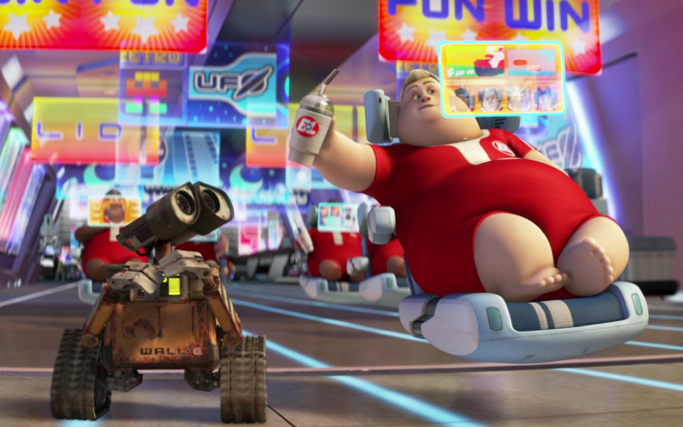I as designer want to create (mainly) simple devices and/or systems to make peoples life easy and enjoyable. With this I don’t mean a completely automated house where one doesn’t have to do anything. However, I feel like this is a future where we are heading towards. Therefore I want to design these (simple) devices/systems in such a way that we keep or highlight/improve certain experiences instead of automating it. These products either help or improve an experience, but don’t do them for you.

Figure : The type of future I want to design against (scene from Wall-E)

I also find it extremely important that the users of the product will be able to influence exactly what the product does for them and what for example data it collects. The product is theirs and therefore they should have the influence on what the product does and not the other way around where there is gatekeeping and data collection without the user actively agreeing or even knowing about it.

# Goals

***Avoid tunnel vision during ideation in project 2***

* Because I tend to get into tunnel vision quite fast I want to make sure I explore enough different ideas and not go in a straight line in the design process.
* Every week in the Q3 I’ll reflect on whether I’m sticking with one idea or still explore alternatives so that I realize whether I am in tunnel vision or not, this way I can go against it once I realize.

***Document every important activity in project 2 in quality.***

* Since I didn’t always document every activity that was important and therefore missed (quality) evidence sometimes I want to make sure I document every activity in project 2 that has importance to the design process.
* Every week I’ll reflect on what I’ve done relating the project and whether I’ve clear and quality photos or other evidence/documentation for it.

***Implementing prototyping and target groups early in the design process in project 2.***

* I noticed I didn’t include prototyping as much in the earlier stages of p1, however since prototyping is important in my vision and I noticed that I get the most active and creative during prototyping, I want to make sure I implement prototyping earlier in the design process.
* I believe that designing user centered is important and therefore I want to make sure by reflecting on the design process every week that I implement target groups (through personas) already in the first weeks of the design process.

***Stay conscious about my behaviour in my team in project 2 by reflecting every week to make sure I’m both not talking too much or taking too much responsibility.***

* In p1 I noticed I sometimes talk a lot during team meetings especially when I’m enthusiastic which can make it hard for others in the team to get their ideas across. Therefore I plan on reflecting on the teamwork together with the team every 2 weeks and consciously reflect on my behaviour in the team during meetings to realize when and if I’m talking too much. I’ll also not (always) take the leader role since this will make me learn to listen more.
* I noticed I sometimes find it hard to ‘trust’ my team to perform the tasks they were assigned to in time or the best they can and therefore I found it hard to let go of certain tasks during p1 (which made me take to much responsibilities). Therefore by reflecting every week I’ll make sure I focus on my own tasks, and realize when I’m worrying too much about the others so that I can consciously make the decision to let go.

***Improve in 3d-modelling in Solidworks for 3d-printing and connecting it with electrical components to make working prototypes that are a higher fidelity in project 2.***

* Since I want to be able to realize my designs in a (semi) high fidelity, I want to develop in my technology and prototyping skills. I think 3d-printing is essential in a lot of cases to make higher fidelity prototypes that are still easy to iterate. Therefore I want to develop further in 3d-moddeling using Solidworks so that I can get more competent in 3d-printing by making at least one 3d model each week during Q3. Afterwards I’ll review the goal by reflecting on how much effort it takes me to model medium complex/organic, daily life objects like a toothbrush.
* I aim to combine these developing skills in 3d-modelling together with previous knowledge about electronics and the knowledge I’ll gather from CE to make working prototypes of a higher fidelity during project 2.

***Learn HTML and CSS to try and build an interactive website for my final deliverable of PI&V by spending at least 2 hours of learning HTML and CSS every week.***

* By following the Youtube tutorial “HTML & CSS Full Course - Beginner to Pro

” by SuperSimpleDev, I’ll both learn and practice with HTML and CSS at least 2 hours a week during Q3. This way I hope to have enough experience to make my own interactive website for PI&V at the end of Q3.

[***Link***](https://www.youtube.com/watch?v=G3e-cpL7ofc&list=PLEO5g-N8LRmmHwrQNqamhrVYGQ4YIg1N5) ***to the Youtube video I’ll follow.***

***Reflect on my goals and process weekly in a reflective and not descriptive manner during Q3.***

* I’ll reflect every week on Friday on my process on my goals, and general other important activities for either my vision, professional identity etc.
* Every week I’ll look back on my reflection of last week and asses my own way of reflecting shortly to mainly make sure I’m not describing but really reflecting on my activities.